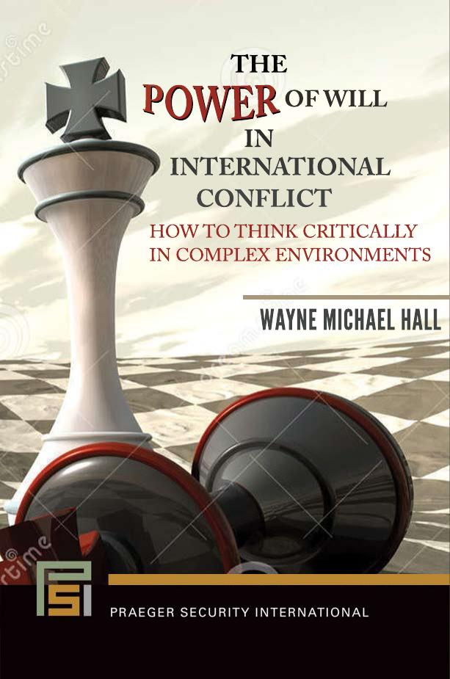
Do You Want to “Win” in Any Conflict?

* * *

This book provides a path to win and avoid defeat! It arms readers with a comprehensive understanding of the nature of Will and affords ways to employ it to win!!

* * *

Human wills lie at the core of all competition and conflict. A person who understands will gains a decisive advantage over the competition…or foe. The full understanding of will, however, proves elusive. In part, that’s because the subject occupies a dark bin of neglect: for all its importance, no body of knowledge has been developed on this pivotal subject. Moreover, the subject is difficult and challenging—some would say, daunting.

One would have thought the military, at least—with its corpus of concepts, doctrines, and curricula—would have addressed will in excruciating detail, both in depth and breadth, since the subject is the nub of military conflict as with any competitive endeavors. But, such is not the case. Even the redoubtable Carl von Clausewitz treated the subject only briefly. Just as Clausewitz’ opus, On War, is the standard-bearer for the subject and theory of war, this book’s destiny is to be the go-to source On Will.

To take existing kernels of tangential thoughts on will and develop a body of knowledge on this perplexing subject is an extraordinary feat indeed. But, that is precisely what the author has done. He has distilled his decades of study and his 40-plus years of combat and peacetime experience as an intelligence officer, teacher, and theorist into a model we can use to understand our opponent (or foe) and, thereby, achieve our aim.

To gain this fountain of knowledge and the capacity to wield its power, you will have to make the time and expend the mental effort to study this book thoroughly, just as many have done with Clausewitz’ On War. Thereafter, you will want to keep the book handy for frequent reference. The effort you will have to exert to achieve this mastery will be considerable and, at times, the journey of learning may become arduous. But, this book’s original content will inspire you to press on. And, awaiting the end of your journey is the intellectual wherewithal to win conflicts of colliding wills…conflicts that affect all human beings each and every day.

Book: The Power of Will in International Conflict
Praeger Security International, to be published late September 2018
Author: Wayne Michael Hall, Ed.D., MS, MMAS, BS, Brigadier General, US Army, Retired
Website: waynemhall.com
Email: hallwm@me.com; hallwm@icloud.com
Phone: 757.647.4371

